Backing up Raspberry Pi Compute Module

Installing multiple Raspberry Pi Compute Modules (CM) from scratch can be a lengthy process. The following instructions show how to create an image file from an existing Raspberry Pi CM installation that is configured as required for your use case. These instructions are for backup and shrinking a Raspbian OS, although they may work with other Raspberry Pi OS’s – it is known that it is not compatible with the Noobs OS.
If you are not familiar with the process of flashing and installing the Compute Module please read the RPi_Compute_Module_Instructions document (or PDF) found here.
In order to backup a CM you will need a Compute Module IO board (see image below), which is also required to flash an image to the CM. You will also need Win32 Disk Imager. Win32 Disk Imager does a byte-for-byte backup of the CM. If the size of the actual used space is much smaller than the CM flash space then it will help to shrink the resulting image file, this can be done with the CM plugged into the IO Board using a keyboard, mouse and monitor, or on a Linux PC with the IO Board in Slave Mode.
Likely you have already used the IO Board to flash the initial image to the CM and configure it. If not you will need to Download and run the Windows installer to install the drivers and rpiboot.exe utility that connects the CM as a USB mass storage device.
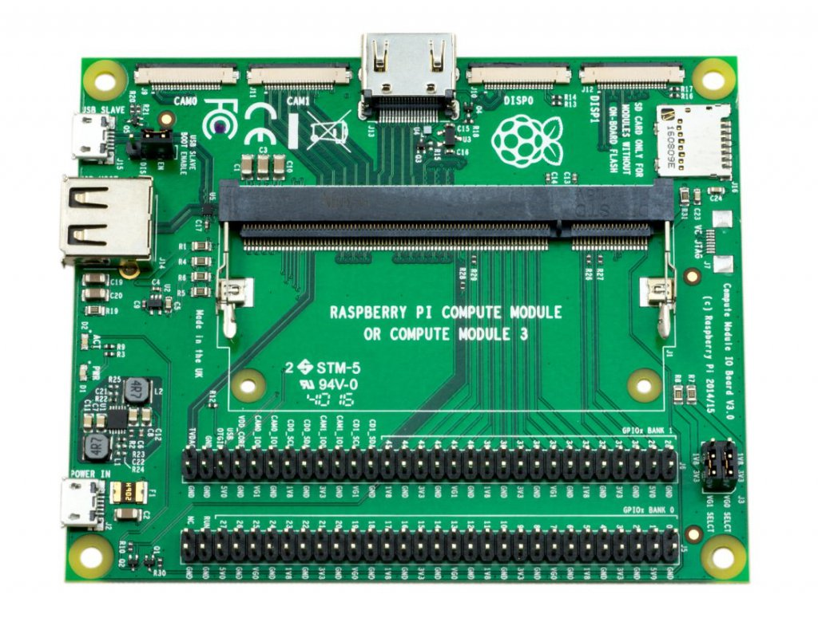
Once the Compute Module has been installed and configured as needed and is ready to backup, it’s important that it is shut down properly;
sudo shutdown -h now
Then disconnect the power from the IO Board, set the J4 (USB Slave/Boot Enable) jumper to the USB Slave position. Connect a micro USB cable to the USB Slave port of the CM and to your PC, then connect another micro USB cable to the Power In port of the CM. When the power is connected to the IO Board, Windows should now find the hardware and install the driver. Once the driver installation is complete, run the RPiBoot.exe tool that was previously installed.

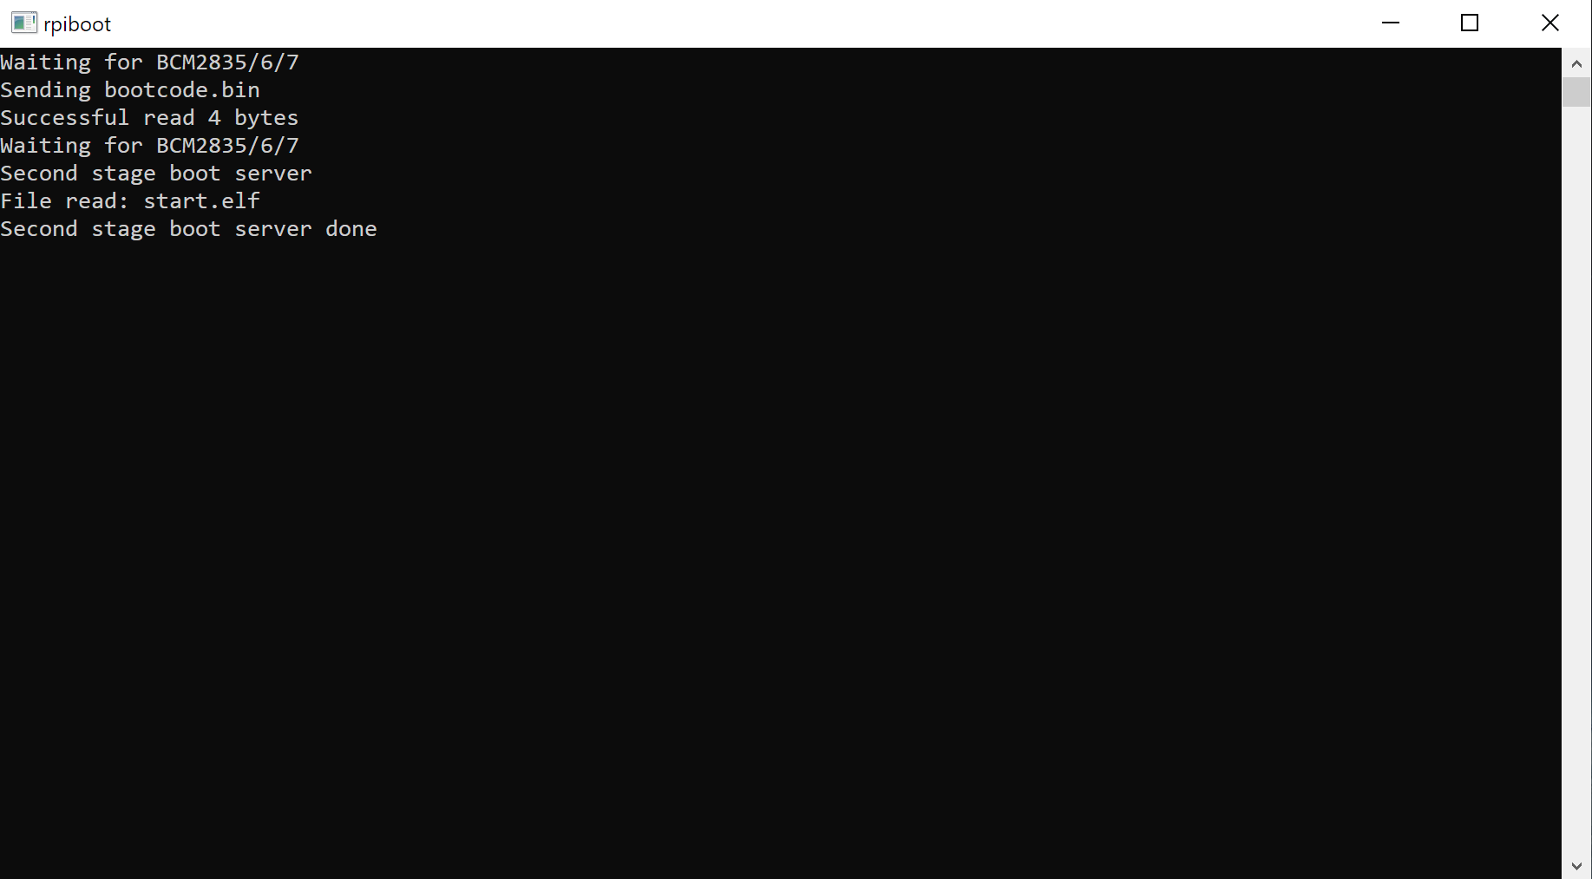

The command window will automatically close after it’s finished. The Compute Module eMMC will show up under Windows as a disk (USB mass storage device). If a dialog box asking to format the disk appears – press Cancel!

When the CM is connected in Slave mode there will be two drives that show up – one is the boot partition and the other is the data partition. Run Win32DiskImager, click on the folder icon to the right of the Image File input text-box – then select the drive/folder where you want to save the image file and give it a name. Next select one of the two compute module drives from the Device dropdown.

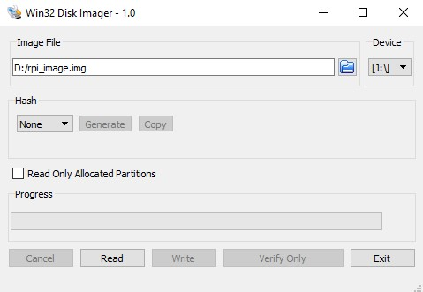

Then click the ‘Read’ button to start the image backup process. If you are backing up a 4gb CM the process won’t take too long, but a 32gb will take a considerable amount of time – be patient!
When the backup is finished you will find that the backup file is the same size as the flash of the CM that is being backed up – a 4gb flash will result in a 4gb backup image, a 32gb flash will be 32gb – no matter how much space is actually being used. The next step is to shrink the image to a more reasonable size, which will both save space on your drive and take less time to restore to the same or another CM.
The process of shrinking the image file can be done directly on the CM if connected to a keyboard, mouse and monitor – a USB hub will be necessary. Since the file is so large, it must be copied to either a USB thumb drive or hard drive, and the file system on the drive must be both capable of the file size, and compatible with the Raspbian OS. The easiest option is NTFS, as it is supported in both Windows and Linux, but in order to write to a NTFS drive with Raspbian you will need to install one package;
sudo apt-get install ntfs-3g

After installing the above package you will need to reboot the CM;

sudo reboot

The following steps are the same for either Linux PC or CM. Connect the USB memory stick or Hard Drive containing the image file. Although the backup process can be done manually it is a long process and using a script file to automate it is much easier. I found this script which works very well to shrink the image file. The link has the instructions to install and run the file. In case the site is no longer available I will repeat the instructions here and include the script in the directory where this document is hosted. Enter the following commands;

wget https://raw.githubusercontent.com/Drewsif/PiShrink/master/pishrink.sh

chmod +x pishrink.sh

sudo mv pishrink.sh /usr/local/bin

Then enter the following command to start the shrinking process;

sudo pishrink.sh -s imagefile.img newimagefile.img

Where ‘imagefile’ is the name of the image file, and newimagefile is the name of the shrunk image file. If the -s option is given the script will skip the autoexpanding part of the process. If you specify the newimagefile.img parameter, the script will make a copy of imagefile.img and work off that. You will need enough space to make a full copy of the image to use that option.

Or enter;

sudo pishrink.sh -s imagefile.img

to create the shrunk image from the existing file. Once the shrinking process has completed the resulting image file can be written to any Raspberry Pi Compute Module of the same (or larger) size memory as the one which the image file was created from. After the image file is written the OS will automatically expand the file system to the full size of the Compute Module memory on first boot. Instructions on how to write the image file can be found here in both MS Word or PDF format (RPi_Compute_Module_Instructions).

